Cedar Children’s Academy
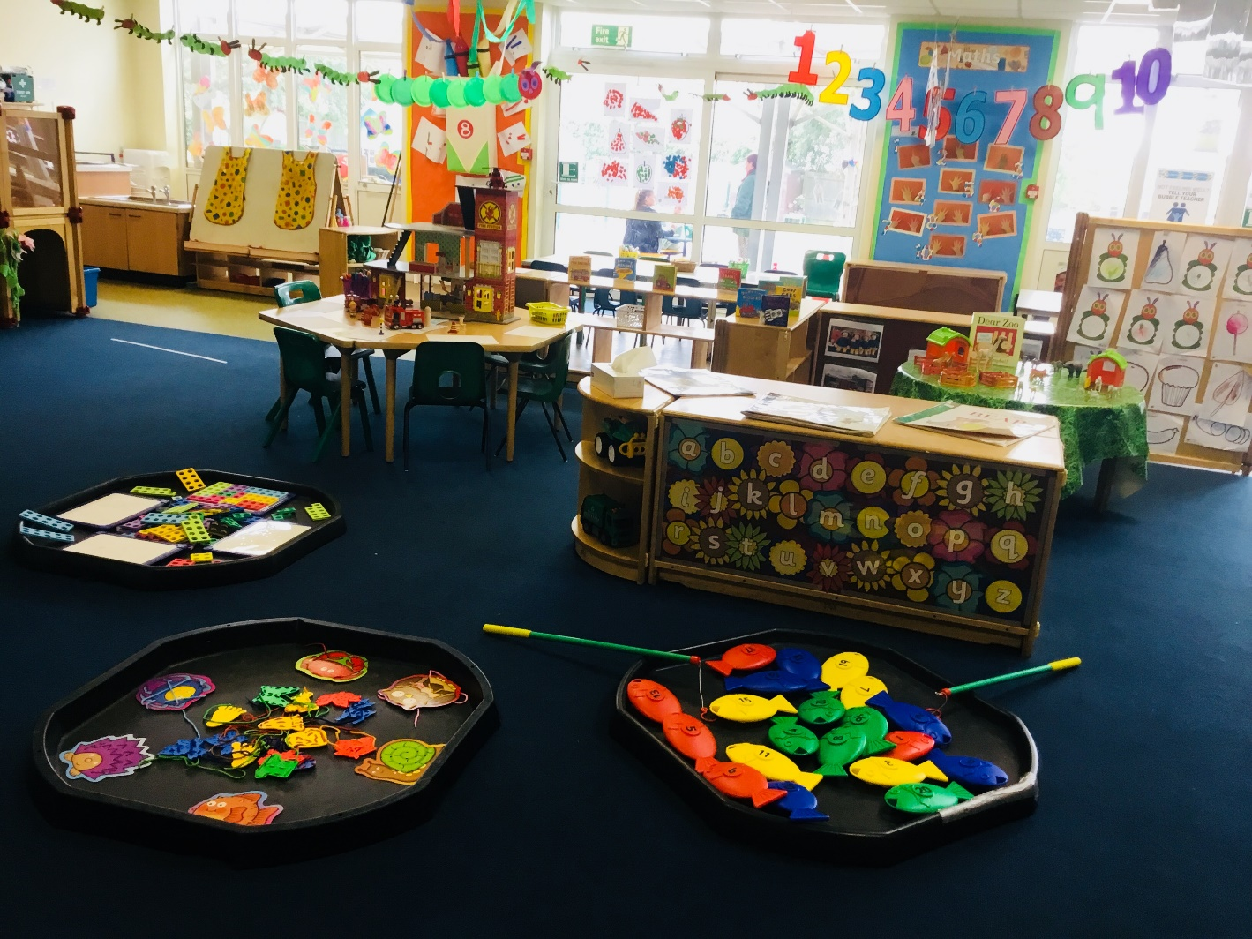

Welcome to Nursery Class

Welcome to Nursery
Miss Sutton Mrs Watson
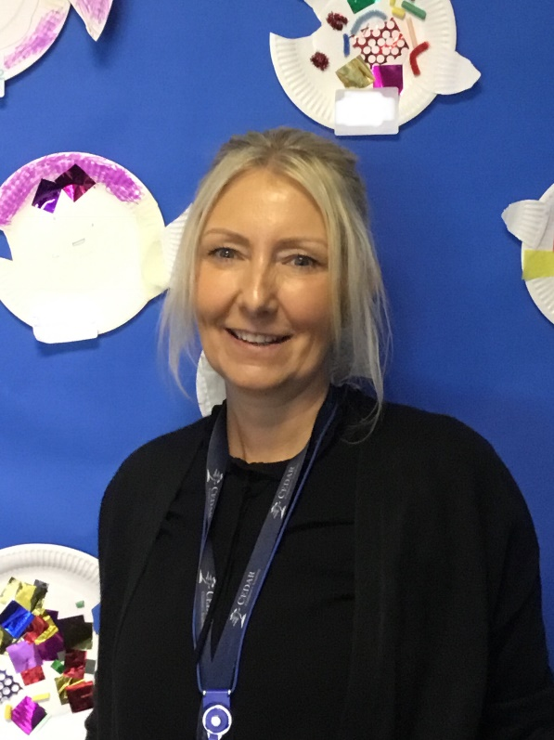
(Nursery Teacher) (Nursery Nurse)

Mrs Froggatt
(Nursery Nurse)
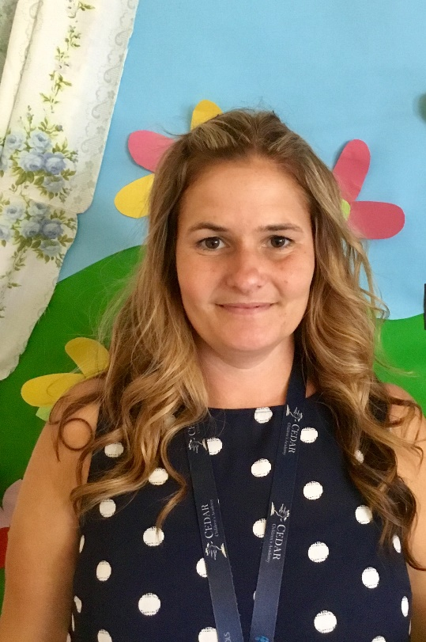

I would like to start by welcoming you
to Cedar Children’s Academy and hope your
association with the school will be a long
and enjoyable one.
NURSERY HOURS

Morning Session – 8.40 – 11.40am (the gate opens for you to collect your child from 11.30am)
Afternoon Session – 12.25 – 3.25pm (gate opens for you to collect your child from 3.10pm)
30 hours – 8.40am – 3.25pm Monday to Thursday, 8.40am – 11.40am Friday, additional hours are payable
(gate opens for you to collect your child from 3.10pm)
Starting nursery is a new and exciting experience. However, both parents and children can sometimes feel apprehensive about the changes ahead. At Cedar Children’s Academy, we aim to make this transition as smooth and as positive as possible. Below are some of the things we do to support your child’s move into nursery and some suggestions of what you might like to do as parents.

Parent Meetings

During the meeting you will be able to chat to the nursery teacher about your child, including their previous childcare experiences, their general development, their interests and share other relevant information or concerns you have about them starting nursery. Information shared during the meeting helps nursery staff plan for your child’s first session and ensure the move into nursery is as smooth as possible.

Starting Nursery
Help your child to become as independent as possible by encouraging and helping them to:
• Use the toilet and wash their hands
• Put on and take off their coat
• Use a tissue to wipe their nose
• Share toys and take turns
• Put their toys away

Ensure you have filled in and returned the various forms included with your nursery pack. Forms should be returned to the school office.

We enjoy role-play – we learnt about ‘Pirates’ last summer

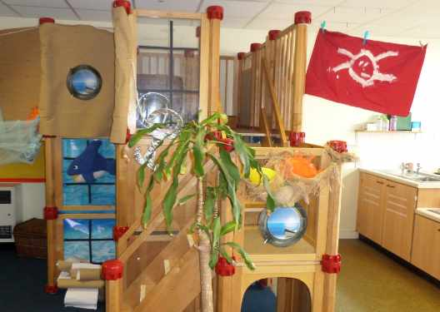

We enjoy counting, looking for shapes and sorting objects by colour and size in the maths area.
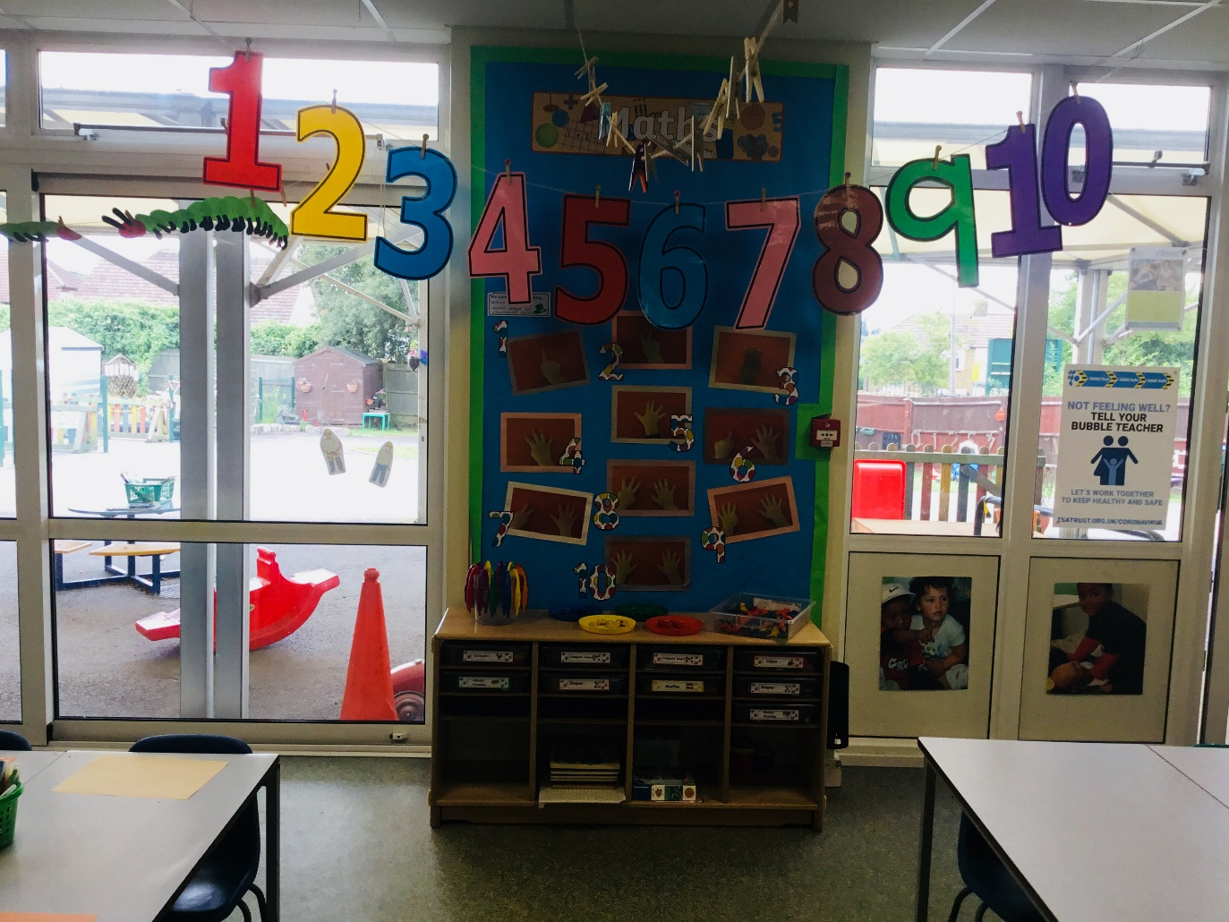

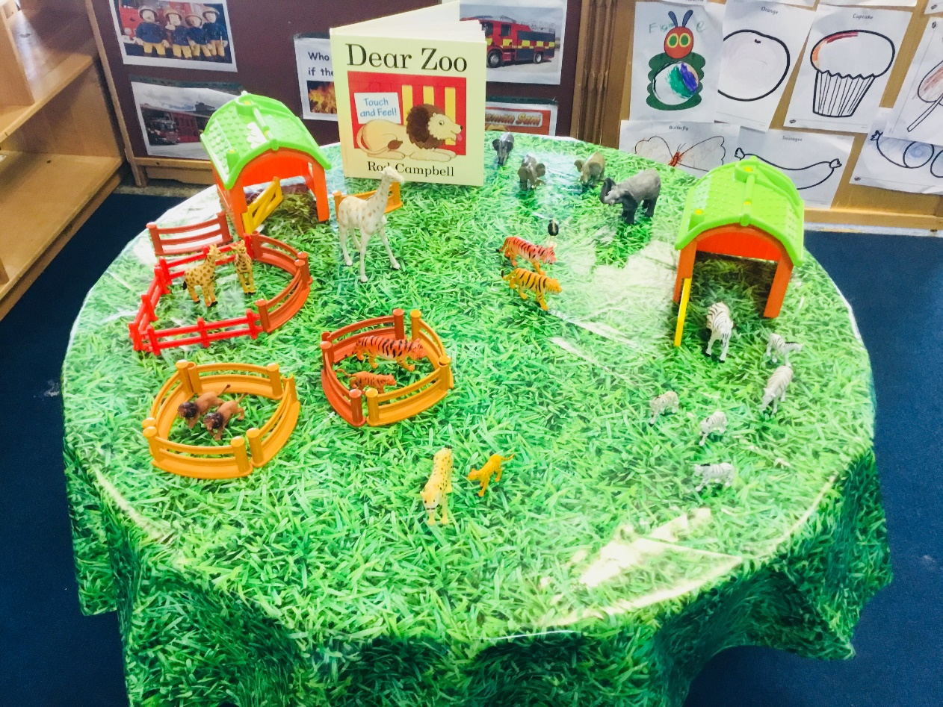
There will be lot of activities set up for your child to play with during their session

We enjoy learning outside – can you ride a tricycle?
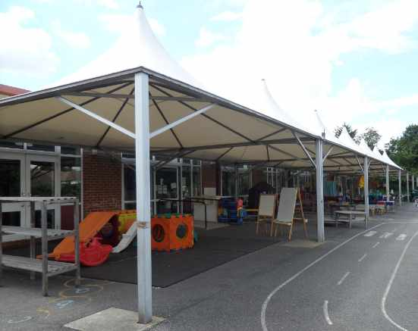

The class library – we enjoy listening to our favourite stories
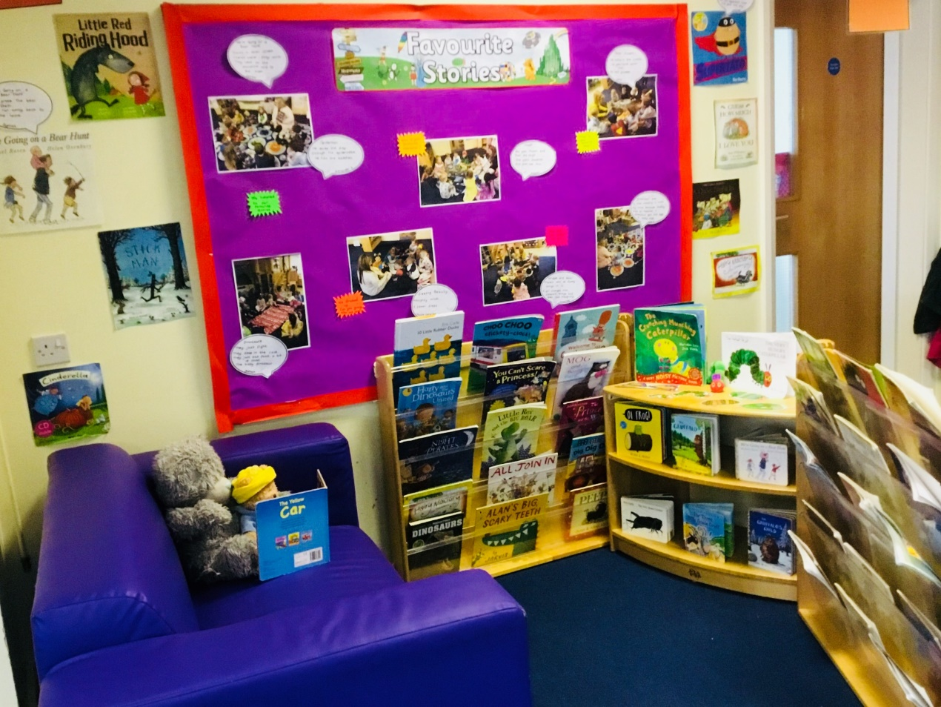

We explore using open-ended resources
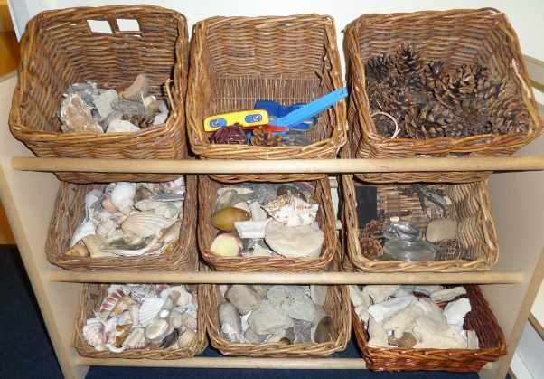

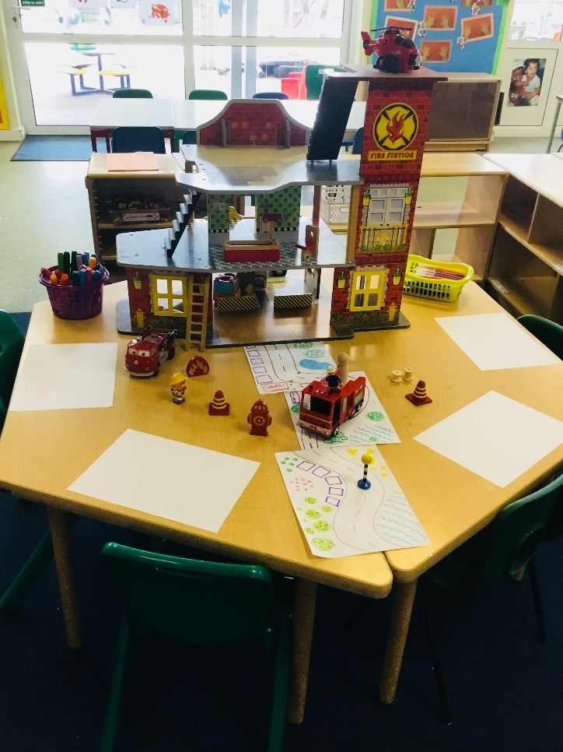
Small world play & mark making

What could you build with the blocks?

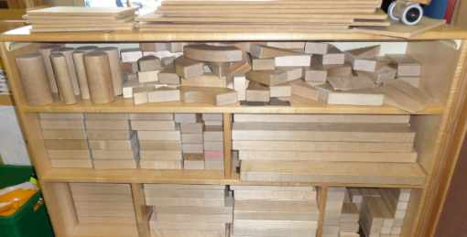

We look forward to see you on your first session at nursery

If you have any queries feel free to contact the school on 0333 360 2105, or email us at,
office@cedarchildrensacademy.org.uk
School website:
cedarchildrensacademy.org.uk

